Are you interested in being a host family??

The Jayhawk Collegiate League prides its teams on creating an environment in which elite college players can compete against high level talent. The Great Bend Bat Cats, along with the League, would greatly appreciate anyone who can participate in providing an opportunity for players to call Great Bend home for two months.

A vital part of a successful season is to have host families provide housing for the players, giving them support and a family atmosphere for the summer.

These young men will have a positive influence in our community and in your home. Many past Host Families have developed friendships with the players they have welcomed into their homes and have enjoyed watching their players progress in their lives on and off the field.
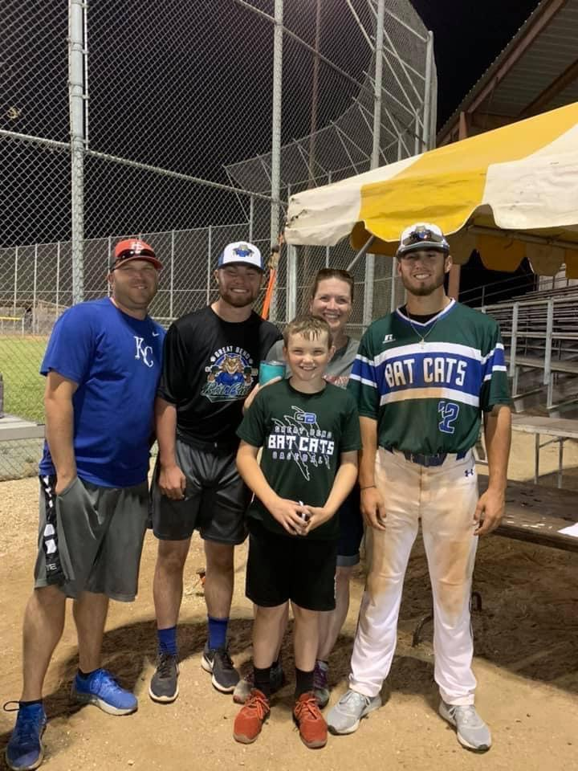
This is a great opportunity to receive an inside look at the trials and tribulations of an aspiring professional baseball player.
If you or someone you know would be willing and able to be a host family, please let us know! Please contact our Housing Director, Roger Ward, at (620) 282-8159 or email him at gb.batcats.ks@gmail.com with any inquiries.

The Great Bend Bat Cats Baseball Club will be comprised of college baseball players from across the nation. The players spend the entire summer (May 28 – July 25) in Great Bend playing in the Jayhawk Collegiate League. League opponents of the Great Bend Bat Cats include teams from Augusta, Derby, Haysville, Hutchinson, Junction City, Kingman, Newton, and Wichita. In addition, the Bat Cats may play local teams from other leagues to fill out a schedule of regular season games, as well as tournament games in the NBC World Series.

While in Great Bend, these young men stay in the homes of local host families. The players are not paid and have very little free time to work while living in Great Bend. Therefore, they will need affordable living while they are far from home. Host families make it possible for the Bat Cats to recruit the best players from across the country, in addition to allowing local kids to have a team to play on where they call home! Please consider opening your home to a Great Bend Bat Cats player this summer!

Host Family Responsibilities:
- Provide living accommodations which include: a bed, a clean environment, and a positive family atmosphere. A player should have access to comfortable living environments throughout the home including a working clean restroom facility. While these do not have to be private non-shared accommodations the player needs to feel comfortable living in the areas of your home that you open to him.
- Access to meals/food in the home when the player is not traveling.
- Access to in-home laundry facilities.
- Participate (if possible) with your player and his family during family weekend.
- Players must be able to come and go from the home according to their game schedule (i.e. arriving home very late from an away game)
- Allow Bat Cats board members to inspect accommodations if needed.

Transportation is NOT a host family responsibility!

Benefits of being a host family:

- Get to know a potential professional baseball player.
- Good family entertainment.
- Role model for host family children.
- Get to know players and families from all over the country.
- Lifelong friendships.

- Help make it possible for the Great Bend community to have a summer college baseball team.
- Costs associated with hosting a player are tax deductible.

Great Bend Bat Cats Baseball Club
P.O. Box 201
Great Bend, KS 67530

Frequently Asked Questions:

What happens if a host family goes on vacation?
Once a family gets to know their player, they often choose to let the player continue to live at the home during the vacation period. If the family is not comfortable with this option, the Bat Cats organization will place the player at another host family’s home for the vacation period.

What if a host family decides after a player is placed in the home, that the player is not a good fit for the family? Players recruited to play for the Bat Cats are of the highest skill level and are very well-disciplined. However, if for some reason, the player and family are not a good fit; the Bat Cats organization will immediately move the player to another host family. The Great Bend Bat Cats organization has no tolerance for players with any behavioral issues and will immediately send any problem player home.

When do players arrive and how long do they stay? As a rule, all the players arrive in late May; however, some players have commitments to their college teams that brings them in later. The players will stay until the Bat Cats regular season is over or head to the NBC World Series.

If I do not want to be a host family, are there other ways I can be involved? Absolutely. Consider being part of the “Feed The Cats” Club, volunteer during games, help on a committee, or volunteer during the off-season.

Do all the players have their own transportation? Not all players bring their own vehicles, but most do. Those who do not are placed in host family situations where there is another player either living nearby or in the same home. Under no circumstance should a player use a host family’s private vehicle.

Who do I call to become a host family or if I have more questions? Roger Ward can be reached at 620-282-8159, or by email at gb.batcats.ks@gmail.com

Great Bend Bat Cats Baseball Club
P.O. Box 201
Great Bend, KS 67530

Host Family Contact Information and
Accommodation Form

Name(s): ___________________________________________________________

Address: ___________________________________________________________

Home Phone: ______________________ Cell Phone: ______________________

Additional Cell Phone Numbers: _______________________________________
Email address: ___________________________________________(please print)

Names and Ages of others living in the home (please include children)

_____________________________ __________________________

_____________________________ __________________________

Will player have in home internet access? Family Computer Wireless Access

Pets living in the home: Dog(s) Cat(s) Bird(s) Other: ________________

Do any family members smoke inside the home? Yes No

Type of living & sleeping accommodations available for the player:
Bed Size: King Queen Single Other _________________

Room: Private bedroom Bed in a common area (family room, etc.)
Other _____________________________________________________

Bathroom: Private Shared Bathtub Shower

Other information pertaining to living arrangements or family preferences:

____________________________________________________________________

____________________________________________________________________

I understand that I am agreeing to be a host family for the Great Bend Bat Cats during the ______ season. I further understand my responsibilities to provide a clean, safe, and positive living environment as explained on the previous page. I agree to allow a Bat Cats board member access to inspect living accommodations prior to placing a player in the home or at anytime while a player is living in the home.

Signature: ___________________________ Date: _________

Great Bend Bat Cats Baseball Club
P.O. Box 201
Great Bend, KS 67530

